**Sheet Metal Estimate – Current/Active Part**

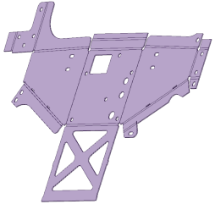

Icon on ribbon

Icon is only enabled if:



* the current/active part is saved
* is sheet metal
* has a flat pattern/unfold associated/saved with it

When user clicks icon:

* result is calculated
* results file is located in the same folder as the part
* result is saved in results file (SM-results.xls)
* if the results file already exists, then the result is appended
* format and information in results file is at end of this specification
* after results are written, a dialog box is presented to indicate calculation has finished

**Sheet Metal Estimate – Folder**

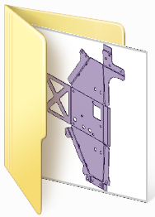

Icon on ribbon

* icon is always enabled, even if no part is loaded



When user clicks icon:

* folder browse dialog is presented to allow user to select a folder
* if there is an active part, then initial folder for browse dialog is folder of active part
* results file is located in the selected folder
* for each SpaceClaim file in the selected folder:
  + result is calculated
* each result is saved in results file (SM-results.xls)
* if the results file already exists, then each result is appended
* format and information in results file is at end of this specification
* after all results are written, a dialog box is presented to indicate calculation has finished

**Results File – Format**

Default name is “SM-results.xls”

Information and format:

|  |  |  |  |  |  |  |  |  |  |  |
| --- | --- | --- | --- | --- | --- | --- | --- | --- | --- | --- |
| **Part Name** | **Sheet Metal** | **Flat**  **Pattern** | **Gauge** | **Area** | **Perimeter** | **No of**  **Bends** | **No of**  **holes** | **LAR**  **Height** | **LAR**  **Width** | **Date-Time** |
| SheetMetal1-flat.scdoc | True | True | 1.5 | 130020.232 | 4700.7505 | 15 | 29 | 463.4 | 680 | 23/03/13 10:38 |
| Test-part1.scdoc | False | False |  |  |  |  |  |  |  |  |

Column information:

* Part Name
  + file name of SpaceClaim file including extension
* Sheet Metal
  + true if file is a sheet metal part, false otherwise
* Flat Pattern
  + true if file has an unfolded, sheet metal, flat pattern, false otherwise
* Gauge
  + thickness of sheet metal part
  + millimetres
* Area
  + surface area of top face of sheet metal part
  + millimetres^2
* Perimeter
  + perimeter of top face of sheet metal part
  + including outside perimeter and all piercings
  + millimetres
* No of Bends
  + number of bends
* No of Holes
  + number of holes or piercings
* LAR Height
  + least area rectangle (LAR) height
  + millimetres
* LAR Width
  + least area rectangle (LAR) width
  + millimetres
* Date-Time
  + date and time result calculated
  + format is yyyy-MM-ddTHH:mm:ss eg 2012-03-10T10:24:33